Linux Package Management

APT Installing Packages Exercise
Lets install some software. Below we have identified some packages that are available from the default Debian package repository. Your task is to install the software and provide some screenshots of the software running in virtual box.

Abes Amazing Adventure
Description | sudo apt show abe  side-scrolling game “abe’s Amazing Adventure”  A scrolling, platform-jumping, key-collecting, ancient pyramid exploring game, vaguely in the style of similar games for the Commodore+4. The game is intended to show young people all the cool games they missed.
command | sudo apt install abe
Repository url | http://ftp.debian.org/debian/pool/main/a/abe/
screenshot | 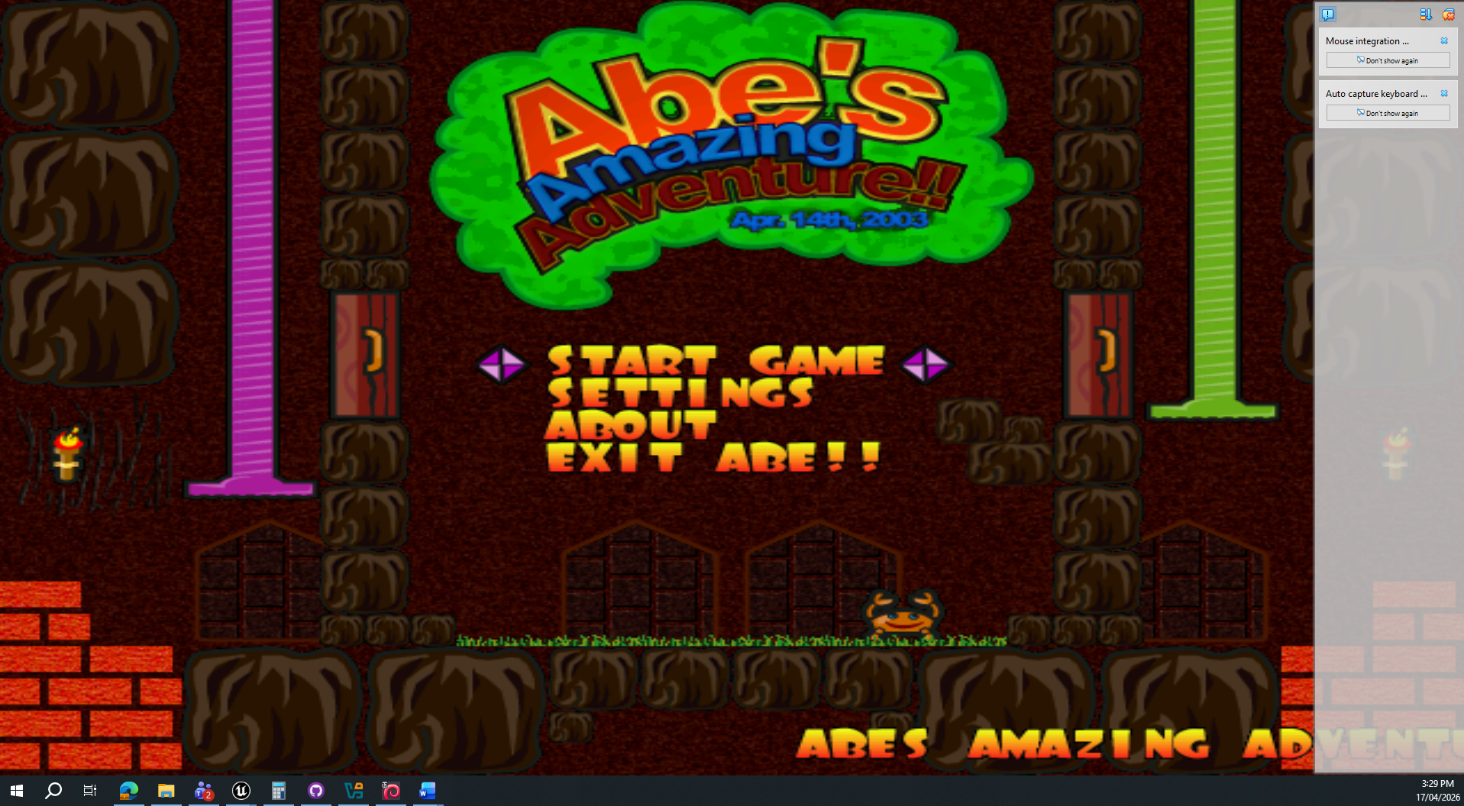

Pingus
description | Sudo apt show pingus  Free Lemmings(TM) clone pingus is a free clone of the popular Lemmings game.  Your goal is to guide a horde of penguins through a world full of obstacles and penguin traps to safety. Although a world full of obstacles and penguin traps to safety. Although penguin (unlike lemmings) are rather smart, they sometimes lack the necessary overview and now rely on you to save them.
command | sudo apt install pingus
Repository url | http://ftp.debian.org/debian/pool/main/p/pingus/
screenshot | 